Department of

JEWISH THOUGHT

Newsletter 2018

What is
Jewish Thought?
p3

TABLE OF CONTENTS
About the Department
The Department of Jewish Thought was created to serve as a multidisciplinary research and academic department focused on teaching and scholarship related to the contributions of the Jewish tradition in the development of Western civilization. Our mission is to foster knowledge, inquiry and scholarly
excellence to better understand Judaism, along with its contributions to a deeper understanding of current agendas and the social challenges of humanity at large.

Throughout its long and diverse history, a central and unifying feature of Judaism is its emphasis on ethics, on biblical and rabbinic teachings of morality, and the prophetic call to justice. Nourished by the enormous spiritual, intellectual
and cultural contributions of a long and productive history, and of a pluralist tradition which remains alive and vibrant in today’s world, the Department of Jewish Thought is especially attentive
to the grand tradition of Western philosophy and to contemporary literary theory and criticism. We invite you to follow our growth as we strive to excel in teaching and scholarship.

In this Issue:
3 ››

4-5 ››

6-7 ››

8-9 ››
10 ››
11 ››

Letter from the Chair What is Jewish Thought?

Faculty News
› Recent Book Releases

Meet Our Students
› Student Achievements
› Reflections

Recent Lectures and Upcoming Events

An Interview with Gordon and Gretchen Gross

Alumni Corner

EDITORIAL STAFF
UPDATE
NEW MASTER’S DEGREE IN JEWISH THOUGHT
The new MA in Jewish Thought degree has been approved by SUNY-central, and is now awaiting final approval by the State Education Department.
EDITORS
Gina Cali-Misterkiewicz,
Elin Hawkinson, Jamie Farrugia
DESIGN AND PRODUCTION
Renee Ruffino, Pierce Strudler

CONTACT US

On the cover: Hanukkah candles

Department of Jewish Thought University at Buffalo
712 Clemens Hall
Buffalo, NY 14260-4680

CALL: (716) 645-3695
EMAIL: jewish-thought@buffalo.edu

VISIT: arts-sciences.buffalo.edu/jewish-thought
Photo: Sergey Dolgopolski

LETTER FROM THE CHAIR

ear students, colleagues and friends of the Department of Jewish Thought and the greater
D
Buffalo community,
The Department of Jewish Thought has entered its third full academic year. Please let me share a vista of our rapid progress and growth in research, teaching and service to the community, and—most importantly—express my deep appreciation of all your support. Here are some quick facts:
In the 2017-2018 academic year, we increased the number of students who have worked with our professors from approximately 300 to over 430, intro- duced new courses, and drastically increased the number of minors and majors from 11 last year to 21 as of May 2018.
In just two years, our faculty brought to publication four books, published many articles, worked at the fore-
front of academic research in Jewish Thought, and translated their cut-
ting-edge research into what students learn in the classrooms on all levels, from freshman seminars to larger thematic undergraduate classes to advanced graduate seminars.
The department faculty organized and participated in many international conferences and symposia. They also developed a new format of community lectures with a more interaction-orient- ed atmosphere which now includes two professors conversing about a topic, then inviting the audience to actively participate in the conversation.
We are also excited to announce The Irving M. and Marilyn C. Shuman Visiting Assistant Professor in Jewish Thought! A national search for the prestigious candidate will begin this fall. The scholar and professor will be-
gin their two-year term in August 2019. The growth of our department is vital.
At a time when humanities in general, and the Jewish intellectual tradition therein in particular, become both
the most vulnerable, the most needed resource, to resist a slide from democ- racy to technocracy, your support of the department is more crucial than ever before. The department researches and translates the intellectual recourse the Jewish tradition has to offer to human- ities and to the larger society. I therefore appreciate your support even more, whether it comes in the form of par- ticipating in events, taking classes or sponsoring our new projects in research, teaching and community service.
Please read on, and we invite you to visit our newly designed website at arts-sciences.buffalo.edu/jew- ish-thought to learn more about our plans, and how you can contribute to
our goals by attending/sponsoring our new and existing events or programs.

Yours,

Sergey Dolgopolski, Chair

WHAT IS JEWISH THOUGHT?

The answer to this question is by definition an on-going task, yet here is a beginning:
Reading from right to left, the core concept of Jewish Thought is "thought," understood as a task to which humans are to rise, despite any objectifying approaches they often develop to one another. And the second core concept of Jewish Thought is "Jewish," which
entails perhaps the most self-critical and self-questioning identity in the world— the identity that is constantly unfolding in an ever-challenging relationship of its bearers to the calling of Jacob and his
descendants, the calling of Biblical Israel.

To our past, present and future students:
No matter your background, you might have asked—or were even afraid to ask— one of the most fundamental questions
about oneself: "Who am I?" Your parents, perhaps your religious community,
or your group of peers are naturally suggesting your answers to the other question, "Where are you coming from?" These two questions are very different; and in answering the latter you cannot answer the former. In fact, answering a question with an answer to a different question is a well-known fallacy.
Many groups, tribes and nations sug- gest their members answer the "Who am I?" question by either identifying with, or differentiating from, the Biblical Israel. This holds true for religions such as Christianity and Islam, and for modern nations such as the French, Afghan, Irish or German, to name just a few. And you can come to your own answer to that question by studying how individuals and/or groups answered it and/or failed to.
Understanding the centrality of the fig- ure of the Biblical Israel for the "Who am I?" question for self-understanding of so many different groups, the Department of Jewish Thought provides students of all backgrounds and walks of life with a safe, stimulating and nurturing intel- lectual environment for a genuine (and therefore risky, challenging and exciting) exploration of this and similar crucial questions about their own humanity.
We encourage you to engage in ongoing research and study with the Department of Jewish Thought, and hope we can help you learn how to approach the "Who am I?" question, as well as other core questions of human existence and experience, such as: "What can I know?" "What do I have to do?" or "What can I hope for?"

FACULTY NEWS

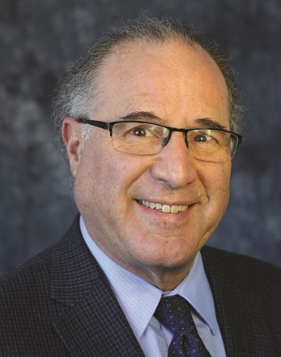
Professor Richard Cohen recently released the article “Levinas on Art and Aesthet- ics: Getting Reality and its Shadow Right,” in Levinas Studies, Vol. 11, eds.
Richard A. Cohen and Jolanta Saldukaityte (Pittsburgh: Duquesne University Press: 2017), while also contributing to several books, including “Emmanuel Levinas,” chapter 10 of Oxford Handbook of Phenom- enological Psychopathology, eds. Giovanni Stranghellini, Andrea Raballo, Matthew Broome, Anthony Vincent Fernandez, Paolo Fusar-Poli and Rene Rosfort (Oxford: Oxford University Press, online published March 2018); “The Deleterious Politics of Plutocracy,” in Sociologia: Revis-
Professor Sergey Dolgopolski’s new book, Other Others: The Political in the Talmud (Fordham
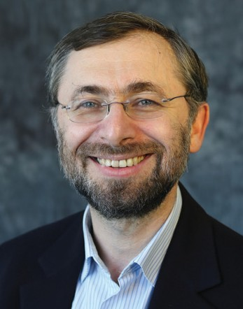
U. Press, June 2018), is now in print. The book is devoted to an in-
tersection of contemporary political the- ory and classical rabbinic literature and thought. He has also recently published three articles: “Jews, In Theory” in Jews and the Ends of Theory (Fordham Uni- versity Press 20180; “How Else Can One Think Earth? The Talmuds and Pre-Soc- ratics” in Das andere Denken. Heidegge- rian and Jewish Thought (Rowman and Littlefield International, London, 2017); and “Suspending New Testament: Do the
Two Talmuds Belong to Hermeneutics of Texts?” in Studia Humana 6(2) 2017.
Prof. Dolgopolski delivered papers at the conference of European Association of Jewish Law in Vienna ( July 2017) and in Buffalo (Oct. 2017), and participated in a panel in the Association of Jewish Stud- ies (Dec. 2017). He is currently working on a new book-length project on the political, literary and legal notion of testifying/citing a (new) law in the Pal- estinian Talmud (Talmud Yerushalmi)
in the broader context of classical and contemporary Jewish literature, literary and critical theory, and he is also editing a collective monograph on the relation- ships between Talmud and Philosophy for Indiana University Press. Prof.
Dolgopolski continues to serve as chair of the department.

ta Quadrimestrale di Scienze Storiche e So- cioli, Vol. 51, No. 3, 2017; 19-30; “Emmanuel

Levinas,” in Oxford Bibliographies in Jewish Studies, ed. Naomi Seidman (Oxford: Oxford University Press); and “Emman- uel Levinas,” in Bloomsbury Handbook of Literary and Cultural Theory, ed. Jeffrey R. Di Leo (London: Bloomsbury, 2018). Prof. Cohen was invited to present lectures both locally and internationally this past academic year. He currently is working on three books: Politics of Humanity (co-au- thors, Tito Marci and Luca Scuccimarra); Religion, Heidegger and Levinas (co-author, Algis MicKunis); and A Theory of Injus- tice: For an Ethical Politics, all of which
are targeted to be completed in 2019. Prof. Cohen is the Director of the Levinas
Philosophy Summer Seminars. This year’s seminar, held in Paris, France, July 2-6, 2018, was titled: “Justice and Ideology.” He was also recently invited to be the keynote speaker at two events: The 13th Annual International Conference of the North American Levinas Society on the topic of “Levinas, Displacement and Repair” and the 16th annual meeting of Psychology for the Other Conference on the topic of “The Movement and Meaning of Justice.”
Professor Alex Green’s first book, The Virtue Ethics of Levi Gersonides, which was pub- lished in hardcov- er in 2016, will
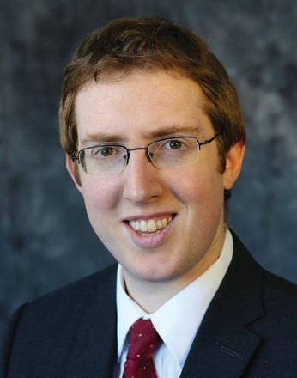
be coming out in paperback in Janu-
ary 2019. It was recently reviewed in The Journal of the History of Philosophy, and reviews are forthcoming in other aca- demic journals. His second book, Joseph Ibn Kaspi: Power, Progress and the Nature of History, was recently accepted by the State University of New York (SUNY) Press and will be published in 2019. He continues his research on Gersonides with a paper entitled “Gersonides on Job’s Ethical Error,” which he presented in January at the Society of Jewish Ethics 2018 Annual Meeting; he is currently revising this paper for publication. In addition, Prof. Green is working with
Dr. David Horwitz (Yeshiva University) on an English translation of Gerson- ides’ commentary on Genesis, entitled
Gersonides’ Lessons (To’alot) on Genesis. He will be giving two lectures in the fall of 2018. He has been asked to speak to UB’s Department of Philosophy on
“Freedom and Determinism in Medieval Jewish Philosophy,” and has been invited to participate in the Maimonides Centre for Advanced Studies at the University of Hamburg (Germany) conference on “Scepticism and Anti-Scepticism in Jew- ish Averroism,” where he will speak on the topic of “Gersonides and Ibn Kaspi on Certainty about the Future.” Prof.
Green recently completed his first year as Director of Undergraduate Studies in the Department of Jewish Thought, and with the help of colleagues, has taken an active role in increasing the number of majors and minors in Jewish Studies. He organized the department’s first end-
of-year celebration for its graduates, where four recent graduates spoke in praise of their experience studying in the department, and about the high level of instruction received in their depart- mental courses.

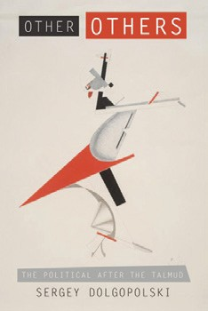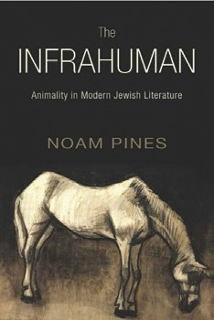FACULTY NEWS

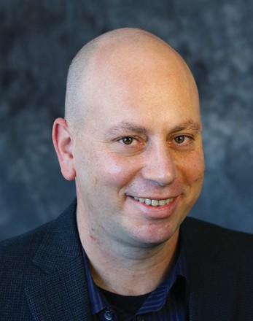
Professor Noam Pines has finished his new book, The Infrahuman: Ani- mality in Modern Jewish Literature, which will be pub- lished by SUNY Press in August
2018. The book explores a little-known aspect in major works of Jewish litera- ture from the period preceding World War II, in which Jewish writers in Ger- man, Hebrew and Yiddish employed fig- ures of animals in depictions of Jews and Jewish identity. Rather than serving as figures of Jewish “self-hatred,” the book argues that Jewish writers employed animals as a way to question prevalent notions of Jewish identity, and to subject pejorative designations of Judaism to literary elaboration and to philosophical negotiation. Additionally, Prof. Pines has published an article entitled “A Rad- ical Advocacy: Suffering Jews and Ani- mals in S. Y. Abramovitsh’s Di Kliatshe” (Jewish Social Studies, Number 2, Winter 2018, 24-47.) The article focuses on one of S. Y. Abramovitsh’s early works, in which the Jewish people are allegorical- ly depicted as a decrepit horse, showing how Abramovitsh came to promote a radical ethical position on the question of human and animal suffering. The awareness of a dimension of suffer-
ing shared by both Jews and animals provides an alternative account to the conventional debate on the Jewish Ques- tion. Instead of a formal affirmation of universal human rights, in Abramov- itsh’s work the relation to questions of Jewish identity remains informal and marked by attentiveness to the dehu- manized aspects of Jewish existence.

Prof. Pines is also contributing a critical introduction and a Hebrew translation of the three chapters from Hans Ulrich Gumbrecht’s The Broad Present, a work dealing with the emergence of a new understanding of temporal and spatial coordinates in the present. This would be the first translation of Gumbrecht— one of the leading literary scholars in the world—into Hebrew. The introduc- tion and translation are forthcoming in summer 2018 in Ot: A Journal of Literary Criticism and Theory of Tel Aviv Uni- versity, a leading Israeli journal in the theory and literary critique. In July 2017, Prof. Pines organized an academic panel about stones in literature in the Ameri- can Comparative Literature Association at Utrecht University. In addition, he has been invited to give a talk on the prospects of Humanism at Stanford University, and—more recently—gave a talk on Nazism in Charlottesville at the Getzville JCC. He is currently working on his new book on Jewish identity and melancholia, and—together with Vivian Liska of the University of Antwerp—is editing a special volume on melancholia for the Journal of Jewish Identities.

Recent Publications
Other Others: The Political After the Talmud by Sergey Dolgopolski, released June 2018 This book puts contemporary
political theory and a literary- theoretical exploration of the core text of Rabbinic Judaism, the Talmud, into both a fruitful
and tensed conversation one with another. In the words of the book's catalogue description: "Denying legal and moral existence to those who do not belong to a land, while tolerating diversity of those who do, stabilizes a political order—
or does it? Revisiting this core problem of contemporary political theory, Other Others turns to the Talmud as an untapped resource for a conception of the political and a take on excluded others
our philosophical and theological traditions have effaced."

The Infrahuman: Animality in Modern Jewish Literatures by Noam Pines, released August 2018
The book explores a little-known aspect in major works of Jewish literature from the period preceding World War II, in which Jewish writers in German,
Hebrew and Yiddish employed figures of animals in depictions of Jews and Jewish identity. Rather than serving as figures of Jewish “self-hatred,” the book argues that Jewish writers employed animals as a way to question prevalent notions of Jewish identity, and to subject pejorative designations
of Judaism to literary elaboration and to philosophical negotiation.

MEET OUR STUDENTS

Student Achievements

2018-19 Fellowship, Scholarship and Award Recipients
Ruth and Isadore Bob Fellowship Fund
Josh Dawson, ABD, received the 2018- 19 Ruth and Isadore Bob Fellowship. Josh is a third-year doctoral student in the Department of Comparative Literature. He will use the fellowship to support re- search on his dissertation entitled Save the Child: Trauma History and Literature in the Holocaust and the Canadian Resi- dential Schools System. This fellowship is made possible through a generous dona- tion by Dr. Sharon Bob Young in honor of her parents, Ruth and Isadore Bob.

The Harold J. and Arlyne G. Levy Award in Jewish Studies
Jordan Einhorn Named 2018 Outstanding Senior
A ceremony on May 3, 2018 honored twenty-eight College of Arts and Sciences seniors for their noteworthy contributions to the College and their individual department or program.
Congratulations, Jordan!
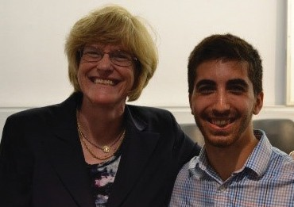
Dean Robin Schulze (left) with Jordan Einhorn

Student Reflections

Congratulations to Our Graduating Seniors!
Jordan Einhorn (’18 BA in Jewish Studies, Political Science, Economics; Minor in Jewish Studies)
William Gorman (’18 BA in History, Political Science; Minor in Jewish Studies)
Nicholas Ottati (’18 BA in History, Political Science; Minor Jewish Studies)
Michael Murtha (’18 BA History; Minor Jewish Studies)
Colin Payne (’18 BA History, Philosophy; Minor Jewish Studies)
Hannah Sulcov (’18 BA Communication; Minor Jewish Studies)

Leah Silverstien received the 2018-19 Harold J. and Arlyne G. Levy Award in Jewish Studies. This award was estab- lished by the Levys to support students who have demonstrated outstanding scholarship and commitment to the study of Jewish culture and heritage.

The Irving M. and Marilyn C. Shuman Scholarship
Sofia Paulino received the 2018-19 Irving M. and Marilyn C. Shuman Schol- arship. The Shumans established this scholarship to support students who have demonstrated outstanding schol- arship and commitment to the study of Jewish culture and heritage.

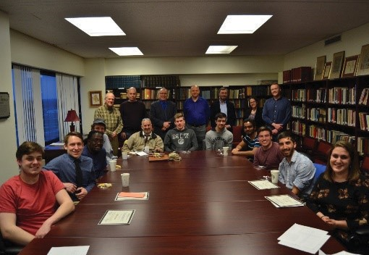

The Department of Jewish Thought hosted its first graduation celebration on April 24, 2018 in the Friedman Library
STUDENTS LOOK BACK ON THE FIRST YEAR OF BIBLICAL HEBREW

“In just one semester, our teacher, Professor Lilia Dolgopolskaia, took us from knowing nothing about Biblical Hebrew or any Hebrew at all, to a place where, in our final, we were reading and translating biblical text. This, in one class a week in one semester.”
Vijay Aswani
– MD, PhD, FACP, FAAP, Student in Introduction to Biblical Hebrew

“The course Introduction to Biblical Hebrew was taught by a superb instructor, Lilia Dolgopolskaia. I and others in the class (both UB students and members of the public) have been thrilled to study this foundational language. Three great religions—Judaism, Christianity, and Islam—all were built upon the Hebrew bible, and much of the world’s subsequent literature and philosophy continues to reference it.”
Edin Bloch
– PhD, Student in Introduction to Biblical Hebrew

“I loved the classes. Professor Lilia Dolgopolskaia is a tough teacher but she really cares and helps you succeed. I learned so much and can now mildly converse in Hebrew. Thanks UB and the Department of Jewish Thought!”
Frank Swerdlin
– Student in Elementary Modern Hebrew 1 and Intermediate Hebrew 2

MEET OUR STUDENTS

THOUGHTS FROM THE FIRST ANNUAL GRADUATION CELEBRATION
“The insight I have gained… has been invaluable to my success as an academic, as a professional, and as an individual.”

Jordan Einhorn, graduating senior

“I have been privileged to be here in this department...I want to thank the faculty and students for making me feel welcome...The faculty are excited and passionate about what they teach and it spills over to the students.”

Will Goreman, graduating senior

“It is here that I learned perhaps the most valuable lesson of my college career: that I am perplexed*...It is as though I, just a familiar face on the floor, was a member of a close-knit community of scholars...I only wish I discovered it, in all its glory, earlier in my UB career.”

Nick Ottati
*Referring to the fundamental introspective questions raised by Jewish Thought classes
“My time in the Department of Jewish Thought has solidified the importance of this one main idea: having an understanding of one’s own identity in combination of understanding the identities of those around you is key to making change in this world... The classes I took in the Department of Jewish Thought…have shaped the way that I understand my own culture
and the importance of understanding others. I developed a better grasp
of history, philosophy, practices and identities that connect and help
structure Judaism. These experiences that I have had, here still to this day, one year later, instill curiosity and expand my critical thinking and how I look at the world.”

– Nicole Caine, BA ’17

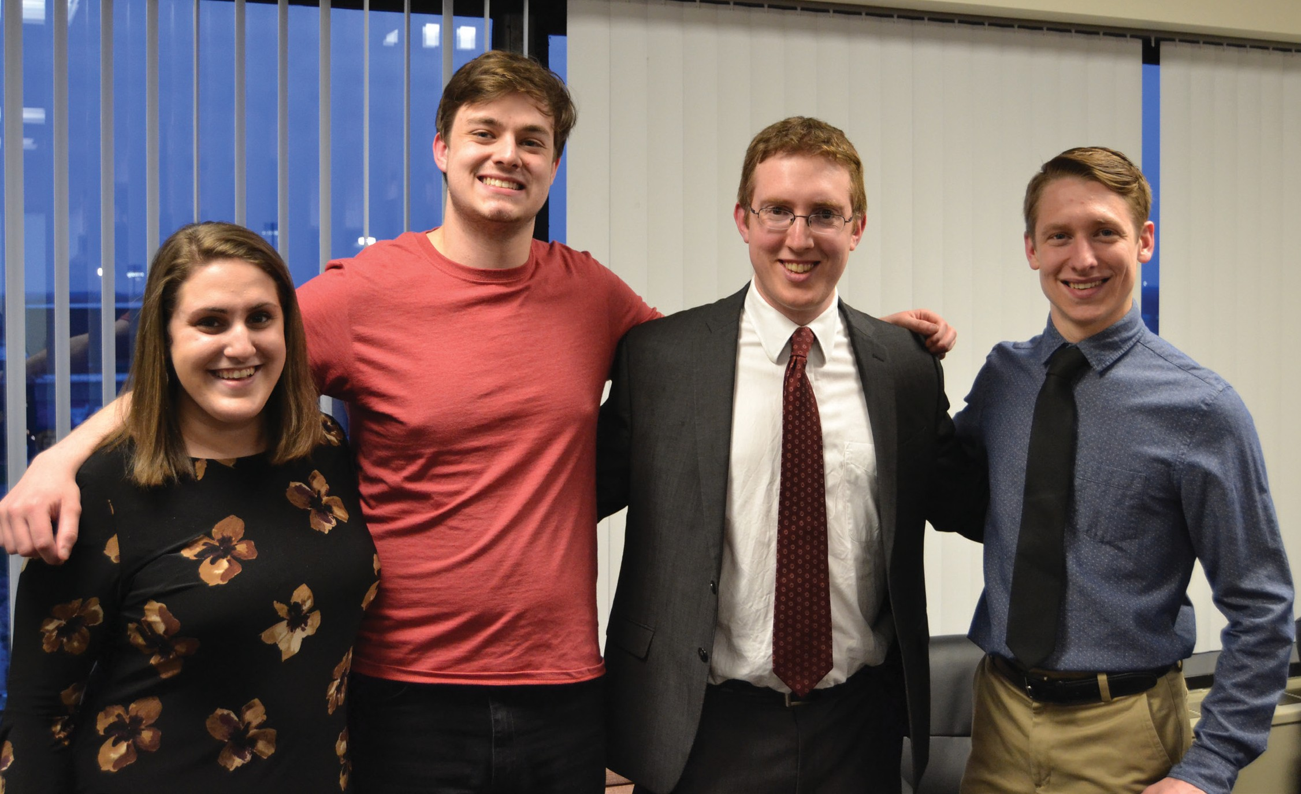
Left to right: Nicole Caine, Will Gorman, Prof. Alex Green and Nick Ottati at the 2018 Graduation Celebration

RECENT LECTURES

DAVID BLITZER LECTURE SERIES

“The Future of Jewish Tradition: What should Jewish Thought Be?”
The Thursday, Oct. 19 David Blitzer Lecture on “The Future of Jewish Tradi- tion: What should Jewish Thought Be?” was a success! Along with the large com- munity and student turn out, we were particularly pleased to welcome Ms.
Helena Schwartz, Ms. Cheryl Stein and Mr. Irving Stein of the Blitzer family. The speakers and the audience engaged in a productive and thought-provoking discussion about Jewish Tradition as a

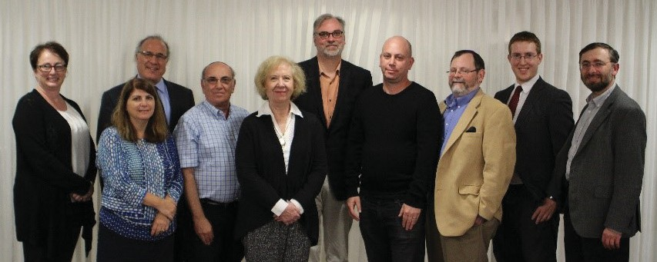
Jewish Thought faculty and distinguished visitors after the Oct. 19 David Blitzer Lecture

POWER AND POWERLESSNESS IN JEWISH LIFE AND THOUGHT LECTURE SERIES

model in which a tradition responds to new challenges thereby moving forward into the future. The topic proved of in- terest for both the community members and the students on campus. One of the important outcomes of the discussion was a shared understanding of the importance of teaching Judaism for all students in a public university. In their responses to the lecture, several stu- dents of different religious backgrounds invariably indicated their excitement about studying Judaism and religion in- dependently of their personal religious connections, or lack thereof. The Blitzer Lecture helped promote the value of learning for the sake of learning, which was its greatest achievement.

Prof. Richard Cohen:
“Why Fascism Again and Now?”
On Nov.14, 2017, Prof. Richard Cohen embarked on a discussion of fascism as Part 1 of our Power and Powerlessness lecture series. One would think that with the rise of fascism in the early twentieth century, especially in Italy, Germany and Spain, and the devastation and mass slaughter of World War II, as well as
the unprecedented moral outrage of the Shoah, that fascism would have been put to rest. But its ugly head seems to be rearing up again, with neo-fascist polit- ical parties garnering millions of votes in several European countries, not to mention the recent darker overtones of
the new American presidency’s apparent
ented “establishment” candidate was defeated in the general election? Are these accidents or exceptions, or is there a deeper and more fundamental realign- ment at work in American politics?

Prof. Noam Pines:
“Jews Won’t Replace Us”
On April 16, 2018, in front of a packed room of community members and UB undergraduate and graduate students, Prof. Noam Pines embarked on his dis- cussion entitled “‘Jews Won’t Replace Us:’ Charlottesville Protest as a Challenge to Jewish Thought.” Based on his analysis of Jewish literary works in modernity, Prof. Pines advanced a notion of unmediated violence as the key concept for a new,

moral confusion evaluating the differ-
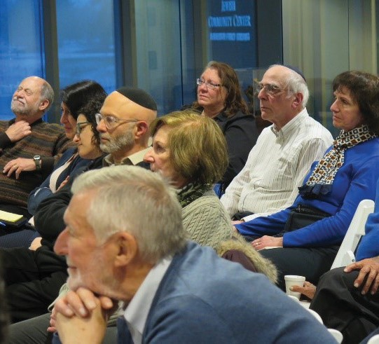
ence between the threats and violence of advocates of racism and antisemitism and those who protest against the same,
or the “message” of disrespect for rule of law broadcast by the pardon of a brazen and unrepentant lawbreaking sheriff in Arizona. What does it mean that at the same time the Republican Party nominat- ed a candidate with no political experi- ence at all, that a political independent and self-proclaimed socialist nearly won the Democratic Party nomination, and that the one experienced and policy-ori-
Audience members listen closely to Prof. Pines discuss the nature of modern Nazism.
more refined understanding of the na- ture of Nazism, both in its classical form in the Third Reich and in its contempo- rary manifestations in the United States and abroad. The dialogue following Prof. Pines’ talk focused primarily on the ques- tion of how his account of Nazism as an unmediated power grab and unmediated violence compares to a view of Nazism and fascism alike as ideologies [states of “false consciousness”] depending, as they always are, on preexisting state struc- tures. The audience left the room with
an advanced understanding of both the complexity and the urgency of the issue.

Introducing next year’s lecture topic! “SACRED and PROFANE”

UPCOMING EVENTS
“Devotion and Relativity, Text and Context: New Frontiers of Jewish Literacy”
Prof. David Patterson: "The Singularity of the Holocaust"
Prof. Alex Green: “Scepticism and Anti-Sceptism in Jewish Averroism”

> Oct. 7-8, 2018 | New York City - The Department of Jewish Thought is co- sponsoring a working group on this topic and has co-organized the group’s first seminar (Oct. 7, 2018 at the Center for Jewish History, Manhattan) and first rabbinic and academic workshop (Yeshivat Maharat, Riverdale). The project is co-organized by Profs. R. Elisha Ancselovits (Hebrew University in Jerusalem and Pardes Institute, Jerusalem); Sergey Dolgopolski (UB);
and Ethan Katz (UC Berkeley). The event is open to the public and alumni and members of the Buffalo community are invited to attend.
Prof. Tamar Rudavsky, Leading Scholar of Medieval Jewish Philosophy

> Oct. 11, 2018, 2pm - | 200G Baldy Prof. Tamar Rudavsky (Ohio State University) is co-editor with Steven
Nadler of the Cambridge History of Jewish Philosophy: From Antiquity through the Seventeenth Century (2009) and author
of Time Matters: Time, Creation and Cosmology in Medieval Jewish Philosophy (2000). Her newest book, Jewish Philosophy in the Middle Ages: Science, Rationalism and Religion, is forthcoming with Oxford University Press. This event is co-sponsored with the UB Department of Philosophy.

> Oct. 22, 2018, 7:30pm |
120 Clemens Hall -
Prof. David Patterson is a distinguished scholar of the Holocaust and author of more than 10 books on the Holocaust, three of which have been published by Cambridge University Press. This event is co-sponsored by the National Endowment for the Humanities, the Department of
Book Presentation: Prof. David Patterson’s The Holocaust and the Non- representable: Literary and Photographic Transcendence (Albany: SUNY Press, 2018)

> Oct. 23, 2018, 12:30-2pm | 120 Clemens Hall - Introduction by Richard Cohen.
This event is co-sponsored by the National Endowment for the Humanities, the Department of Jewish Thought and the Buffalo Holocaust Research Center.
"The Humanity of Politics"

> Oct. 30, 2018
Papers by Profs. Richard Cohen (UB); Tito Marci (University of Rome, La Sapienza, Dept. of Political Science); and Luca Scuccimarra (University of Rome, La Sapienza, Chair, Dept. of Political Science). This event is a follow up symposium to last year’s symposium on “Cosmopolitanism
vs. Globalization.”
> Nov. 12-14, 2018 | University of Hamburg, Germany - Prof. Alex Green will be speaking on the topic of “Gersonides and Ibn Kaspi on Certainty about the Future” at the conference
“Scepticism and Anti-Scepticism in Jewish Averroism,” hosted by the Maimonides Centre for Advanced Studies at the University of Hamburg, Germany.
Book Launch: Prof. Noam Pines’ The Infrahuman: Animality in Modern Jewish Literatures
> Feb. 7, 2019, 6:30pm - Come join us in the Friedman Library to celebrate Prof. Noam Pines’ latest book: The Infrahuman: Animality in Modern Jewish Literatures.
David Blitzer Lecture Series “Nazism and the Jewish Other” by Elliot R. Wolfson, University of UC Santa Barbara

> Lecture planned for the evening of Feb. 26, 2019
Elliot R. Wolfson, a leading scholar on Kabbalah is speaking on “Nazism and the Jewish Other.”
BLIND DATE WITH A JEWISH BOOK
The department invites students and community members to participate in a brand new event series: “Blind Date with a Jewish Book.” Our professors will host a
“meeting” between our guests and a Jewish book in hopes that they will meet again for a second date! Further information and event dates will be posted at arts-sciences. buffalo.edu/jewish-thought

Visit arts-sciences.buffalo.edu/jewish-thought or join the Jewish Thought mailing list to receive regular updates on departmental news and events!

AN INTERVIEW WITH GORDON (LLB ’55) AND GRETCHEN GROSS

No one embodies the principle of Tzedakah, or righteous charity, quite like Gordon and Gretchen Gross. Their incredible generosity throughout Western New York and across the University at Buffalo has made a powerful and lasting impact, perhaps most significantly on the UB Department of Jewish Thought.

What does Boldly Buffalo mean to you?
“If you are going to take a chance, think outside the box. That is being bold.
It’s being bold enough to stand up and say ‘this is who I am, and this is what I stand for.’ It’s important and hopefully you will be a role model for others.”
– Gretchen Gross
Supporting education is paramount to Gordon and Gretchen, and from the start, they’ve championed the department where they established the first endowed professorship.
Particularly within the Jewish tradition, they view education as a way of preserving and ensuring that generations of students—both Jewish and non-Jewish—learn, recognize and value the rich legacy of Judaism and Jewish life.
On the significance of the study of Jewish Thought for today’s young scholars, Gretchen said, “It is important to share and educate students on the history of the Jews, what they’ve gone through, so it is not forgotten.”
Department-led courses, public lectures and programs that connect the faculty and students with the community provide even more valuable opportunities to
develop a sense of identity and understanding. Gretchen believes this extension of the department into the local area is also a way to “look outside the box to engage students in conversation. It is a connection that can encourage students to come to UB.”

A Generous History

According to Gordon, a dedication to Jewish traditions and access to a first-rate education were essential to his success. “It means everything,” he said. “I can only
speak to my experience, but there were no doors that would open up, unless I had a good education. If you want to succeed in life you must have a good education. My parents always said this.”
Gordon also credits his parents for his philanthropic efforts. He recalled how his family always embraced their responsibility to give back.
“I was fortunate that I had parents who were aware of the different needs in the
community,” Gordon said. “I grew up in a culture that says: you help other people.”
While Gordon’s generous spirit was sparked by “a family that was always involved,” he noted: “I don’t think many people come through their childhood and graduate into adulthood and think, ‘Oh boy, I have to help.’ Someplace along the line, through the influence of parents, friends or an experience that changes the way they think and feel, they give back.”
Contributing to the community—their personal form of Tzedakah—is truly a way of life for the Grosses. “Sharing the joy
in giving back—even a small amount can
help. Or you can volunteer services, which is also important,” Gretchen said.
Gordon and Gretchen’s bold and visionary commitment to generosity, combined with their core belief in a high- quality university education and Jewish education, has proven crucial to creating enduring ties between the Department of Jewish Thought, the university and the community.
“We feel strongly that the Buffalo community is important to us and has been good to us. It feels really good to give back, even if it is a tiny little piece, and to a see something grow.”

ALUMNI CORNER

Alumni Update
Congratulations to Nicole Caine (BA ’17) on accepting the position of Develop- ment Associate at the Jewish Federation of Greater Ann Arbor!

Calling all Jewish Thought Alumni
We encourage you to keep in touch with your friends and colleagues, and share what you have been up to since graduation. Please send your news and photos to jewish-thought@buffalo.edu.

Support the Department of Jewish Thought
We are grateful to our many sup- porters. Your generosity—at every level—has been the driving force behind the growth and development of the de- partment. With the help of alumni and friends, we can develop additional vital resources to enhance our department and support students, research projects and programs. To further our educa- tional mission, please consider making a gift online: buffalo.edu/giving/jew- ishthought
STAY

Attending alumni events and programs Mentoring UB students
CONNECTED
You will always be a part of UB. Get involved by:
Attending career events with students

Recruiting prospective students as a UB Admissions Ambassador Connecting with an alumni chapter in your area
Giving to UB and making an impact on students

Following UB and the College of Arts and Sciences on social media

A page from a 15th century edition of the Babylonian Talmud. From Chayim Dimitrovski Edition of “The Remnants of the Bavil”.

College of Arts and Sciences Office of University Advancement 921 Kimball Tower
(716) 645-0841
To get involved, please visit arts-sciences.buffalo.edu/alumni/get-involved
or email UB-CollegeAlumni@buffalo.edu.

712 Clemens Hall Buffalo, New York 14260
Non Profit Org.
U.S. POSTAGE
PAID
Buffalo, NY Permit No. 311

THOUGHT
JEWISH

Newsletter 2018

Discover Their Research

arts-sciences.buffalo.edu/jewish-thought
jewish-thought@buffalo.edu (716) 645-3695
12 2016 Jewish Thought

